Mansfield Hospital
335 Glessner Avenue
Mansfield, OH 44903
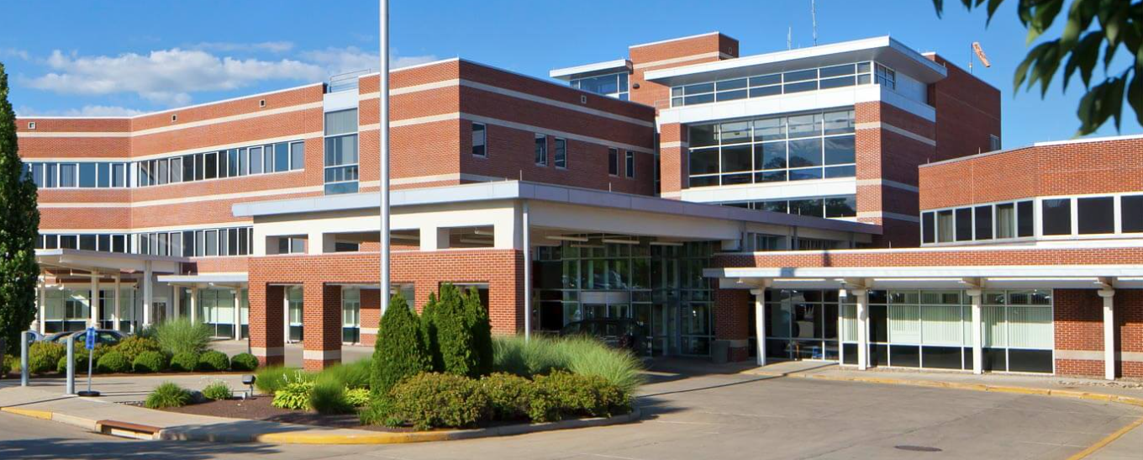
PARKING
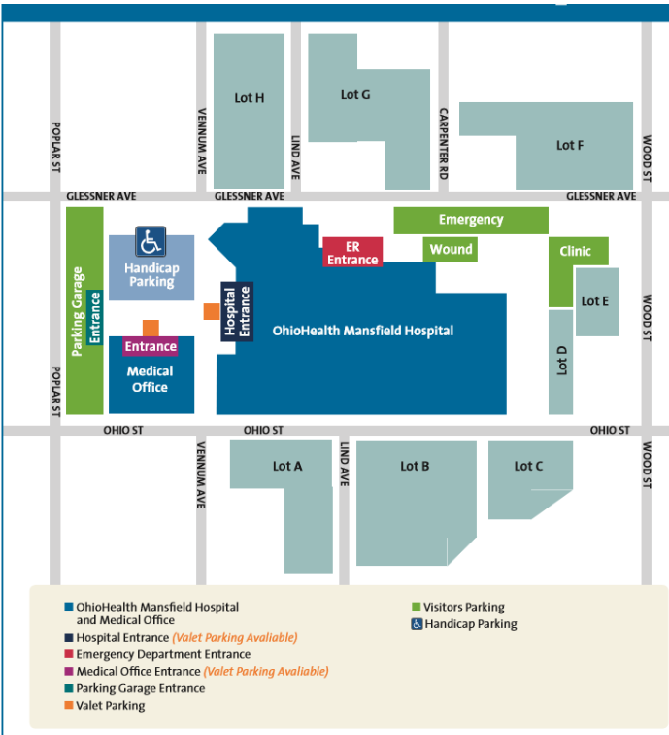

- Park in the F lot or in the gravel behind the G lot.

BADGES
- Protective Services Office-ID Center
-Open Monday through Friday 6:30a-1:30p
- Items needed for badge pick-up
-OPID
-Driver’s license
-Debit/Credit card -- $10.00 badge fee
-Hospital placement information
Please keep your badge for your entire nursing school program. There is a $10 fee for badge replacement.

