 | 
SPECIFIC DEPARTMENTAL ATTIRE  - Rehab Services Physical and Occupational Therapy: employees should wear royal blue shirts and khaki bottoms.  - Surgical Services /Central Sterile: Must wear department approved scrubs.  - Dietary: Culinary style uniforms are required. All Dietary employees are required to wear slip resistant shoes.  - Environmental Services: Navy Blue scrub attire. Khaki pants may be worn with Navy Blue scrub top.  - Facility Operations: Business Casual attire consisting of collared shirt and khaki slacks or skirt. If cap is appropriate, it should coordinate with the facility approved logo.  - EMS: EMS personnel should wear paramedic / EMT uniform.  - Security: Security officers will be in designated uniform.  - Physician Offices/ Clinics: Employees should wear approved color for their office/ clinic in scrub attire and/or polo style shirts. | Business Support Attire  Pants  - Loose fitting, no more than 3in above ankle  - Leggings can be worn with dresses that meets requirements  - NO Denim material or (back pockets and denim stitching) pants.  Skirts and Dresses  - Hemlines on skirts and dresses should be no more than 3in above the knee without high slits.  - Must fit properly  Shirts and Tops  - Appropriate for work setting  - Full sleeves and back should be worn tucked or extend past waistband  - NO graphic tees unless designated by department on specific days.  - Males should wear a collared shirt with tie and jacket as appropriate.  Shoes:  - Shoes should be appropriated for the job and not present a safety hazard to the employee  - NO flip flops  IF IN DOUBT, DO NOT WEAR IT!  *For a more detailed description please reference the employee handbook* | COLQUITT REGIONAL MEDICAL CENTER EMPLOYEE DRESS CODE  Employees are expected to adhere to the established dress code at all times while on duty. First impressions are considered lasting impressions. It is the goal of Colquitt Regional Medical Center to present a neat, professional, and clean image to our customers.  IF IN DOUBT, DO NOT WEAR IT!  *This brochure is a guide. Please reference the employee policy in the handbook for a more detailed descriptions*  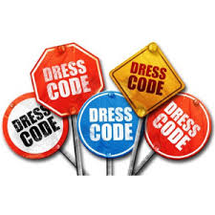
MAKING OUR HOSPITAL A BETTER WORKPLACE ONE DRESS CODE AT A TIME! |  | - Human Resources: 229-890-3538

All employees are expected to:  - Wear clothing that is clean, neat, not faded and fits appropriately.  - Proper undergarments  - NO visible cleavage  - Appropriate use of deodorants  HAIR: Must be cleaned and well groomed, conservative, and of a natural color in appearance.  - In clinical areas, long hair should be properly secured behind shoulders. Hair length and style should not present a safety hazard or cause problems with job functionality. Male employees should keep facial hair well-groomed, clean, closely trimmed and not of excessive length.  MAKEUP: Should be conservative with a natural appearance.  NAILS: Nails must be clean and properly maintained.  - Conservative  - NO peeling/chipping  - Personnel in contact with patient = NO artificial nails  - Should be no more than 1/4 inches in length  - If wearing open toe shoes, toes should be manicured  Proper undergarments must be worn and panty lines should be invisible. Bralette or bra straps should  not show. It is not appropriate for cleavage to be visible. Employees should always present to work  with clean hair and body and appropriate use of deodorants.  PHYSICAL APPEARANCE AND HYGIENE | FRAGRANCES  - Perfume, cologne, or other fragranced toiletries should NOT be worn to work. Please be respectful of our patients and coworkers who have a sensitivity to fragrance.  JEWELRY  - Should be conservative  - Male employees should NOT wear earrings on duty  - Females should wear no more than 3 earrings per ear  PIERCINGS  - NO other visible piercings other than ears should be visible.  - NO gauge/industrial piercings  TATTOOS  - NO visible tattoos while on duty, should be covered professionally.  IDENTIFICATION BADGES  Name badges should be worn on duty at all times  - Worn above waist  - Front of badge visible  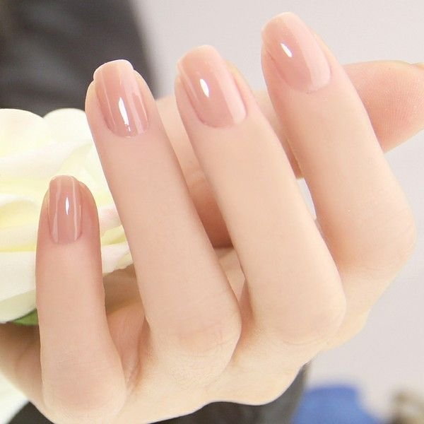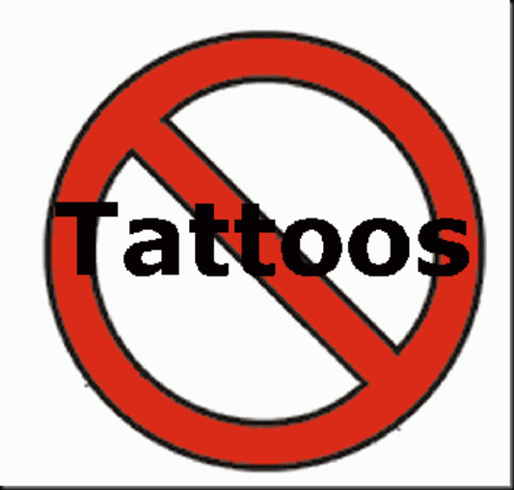 | Direct Patient care/licensed employees  Scrub tops: Royal Blue  - Registered nurses only – may choose to wear a white top or total white uniform  - Long sleeve shirts in either royal blue, solid white, or black may be worn under the scrub top.  - Clinical jackets may be worn in the same color as the top or a Registered Nurse may wear a white jacket with either color top.  - An embroidered monogramed top is allowed with initials or name and title in black or white.  Scrub bottoms: Royal Blue or Black  Shoes: Shoes must be appropriate and safe for job, and neutral in color. Athletic type shoes or clogs are acceptable.  DIRECT PATIENT CARE /NON-LICENSED EMPLOYEES  Scrub tops  - Ceil Blue  - Long sleeve shirts in either solid white or black may be worn under the scrub top.  - Clinical jackets may be worn in the same color as the top.  - Embroidered monogramed top is allowed with initials or name and title in black or white.  Scrub bottoms  - Ceil blue or Black  Shoes  - Appropriate and safe for job, neutral in color. Athletic shoes or clogs are acceptable

