Marion General Hospital
1000 McKinley Park Drive
Marion, OH 43302
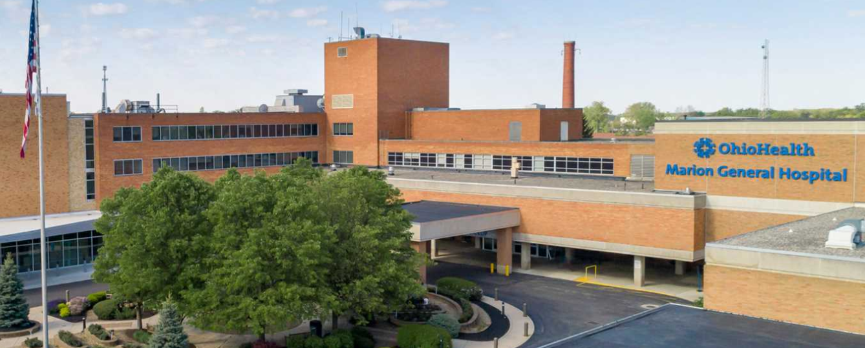

BADGES
- There are no set hours to pick badges up, you need to contact Melanie Parish to set up a time (melanie.parish@ohiohealth.com)
- Items needed for badge pick-up
-OPID
-Driver’s license
-Credit card -- $10.00 badge fee
-Hospital placement information
Please keep your badge for your entire nursing school program. There is a $10 fee for badge replacement.
- You can also pick your badge up at:
Blom Administrative Campus (Tues-Fri ONLY) 7a-3:30p (closed 12-1p for lunch)
3430 OhioHealth Pkwy
Columbus, OH 43202

PARKING-Please park in the associate lot for day, evening and weekend shifts

