Highland Hospital

Faculty Instructor Onboarding

Dear Faculty Instructor,
On behalf of Nursing Professional Development, welcome to Highland Hospital. We are truly grateful for your partnership and the vital role you play in shaping the next generation of nurses.
We are excited to have you and your students join our clinical learning environment. Your presence not only supports student growth, but also enriches our teams and strengthens our culture of learning, collaboration, and excellence in patient care.
We also value the connection between clinical instructors and our staff. Building relationships on the units helps create meaningful experiences for students and fosters a sense of belonging within our organization.
As part of your onboarding, we ask that all required documentation and compliance items are completed prior to the start of your clinical experience. Please review the following onboarding directions. All required materials can be found on our ACEMAPP page: https://collaboration.acemapp.org/e-content/ur-medicine-highland-hospital.
If there is anything we can do to support you or your students, please don’t hesitate to reach out. If this is your first time at Highland, please contact Roxanne_cannarozzo@urmc.rochester.edu to set up an in-person meeting. We would love to review the onboarding process and provide you with a tour of Highland! We look forward to working with you and appreciate the dedication you bring to nursing education.
Warm regards,
Nursing Professional Development
(585)341-6709

Account Initiation, Compliance, and Onboarding
- If new to URMC, please look for an email to complete your URMC account initiation.

- Please notify us if you are new to URMC eRecord or have not used eRecord in the past year. You will be assigned to an in-person class. Once assigned, you will receive an email from eRecord scheduling with class details and access to online pre-learning. Note: Pre-learning must be completed ahead of time to attend the class. Faculty and students are not allowed to access eRecord until this is completed.

- Instructors must complete Faculty Orientation and all assigned mandatory modules initially and then annually in MyPath/Achieve. To access modules, follow the directions below:

For new instructors, please use your school or personal email when self-registering for a guest account with this link: https://rochester.csod.com/selfreg/register.aspx?c=hh-faculty. Once your account is created, the Faculty Orientation will download within a few hours. See below on instructions for logging back in.

For returning external faculty, use this link: https://rochester.csod.com/login/render.aspx?id=externaluserlogin. If you are unable to access your account or need to reset your password, please contact achievesupport@urmc.rochester.edu

When logging in, be sure to use the GUEST USER login on the left!
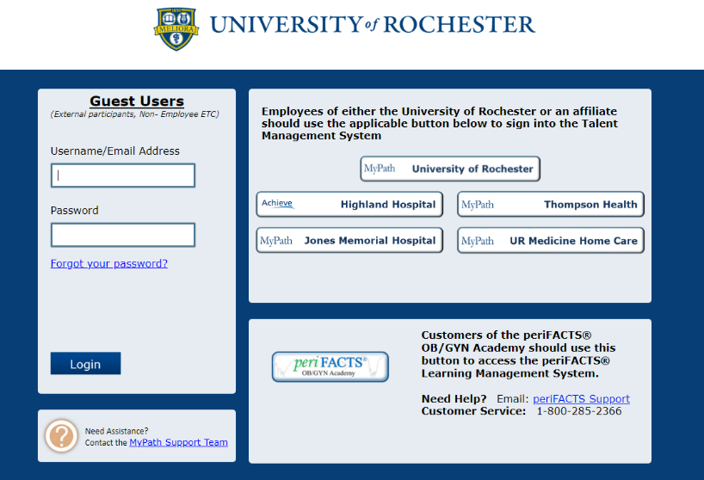

- For URMC employees: email achievesupport@urmc.rochester.edu if you do not see your mandatories in Achieve. If completed on MyPath, submit your transcript to the above email and to Roxanne_Cannarozzo@URMC.Rochester.edu.
- Reach out to manager(s) to schedule a unit orientation and shadow before your first clinical day.

- The required documents must be sent to Roxanne_Cannarozzo@URMC.Rochester.edu, dropped off in the NPD office, or faxed to 585-341-0433 before clinical:
  - Annual Achieve/MyPath transcript showing completed orientation and mandatory modules
  - Stryker competency form (only first-time Highland instructors)
  - Annual Faculty Checklist (annually and for each unit)
  - Clinical Instructor Orientation form (Initially and if instructing on a new unit)
  - Before or on the first day of clinical: Student Orientation Attestation form

- Please ensure you meet compliance in ACEMAPP prior to your clinical start date.

- If you are interested in having your students participate in Safe Patient Handling and Mobility equipment, reach out to Rob Masterman (robert_masterman@urmc.rochester.edu) to schedule training.

Parking, Badging, and Reserving Conference Rooms

- At least two weeks prior to the first clinical day, all faculty instructors and students must submit the following to Support Services at hhservline@urmc.rochester.edu:
  - A professional headshot in JPEG/PNG format saved as the student or instructor’s first and last name and role (please note if the photograph submitted does not comply with Support Services identification standards, they may refuse the right to issue an ID badge until a proper photo is submitted). Please make a note of the assigned unit.
  - Parking registration form (found in ACEMAPP) completed with vehicle license plate, make, model, color, and year
  - A copy of a valid NYS or out of state ID

- Notify inform Support Services via email or (585) 341-7378 when you will be picking up ID badges. Weekend faculty instructors pick up badges from Security in ED unless alternate arrangements are made ahead of time with Support Services. When contacting Support Services, please note that the badges are for a weekend group.

- After unit orientation, go to Support Services on the 1st floor to:
  - Obtain your Highland Hospital Clinical Instructor ID and student badges (refer to note below*). For UR affiliate employees, bring your ID badge. For all others, bring a form of ID.
  - Register for parking (if desired). If you already pay for parking at any UR affiliate, please let Support Services know. Please have available your UR ID or parking permit, license plate, make & model, color, and year of your vehicle.
*Note: It is the responsibility of you and your students to always wear Highland ID badges while on site. The replacement fee is $10. At the end of the semester, all ID badges must be returned to Support Services. However, if expecting to return for future clinicals, individuals may keep their ID badges and contact Support Services for re-activation at the beginning of each semester.
- If desired, please arrange for booking a conference room space as soon as possible with the following contacts: For FMC clinicals, please contact Joyce Riola at joyce_riola@urmc.rochester.edu or (585) 341-0598 with specific dates and times. For all other clinicals, contact Support Services at hhservline@urmc.rocehester.edu or (585) 341-7378. If Support Services or Joyce are unable to make sufficient room arrangements based on your needs, please contact Nancy Kliss at Nancy_kliss@urmc.rochester.edu or (585) 341-6711 or Stephanie Schechter at stephanie_schechter@urmc.rochester.edu or (585)341-7344.

