O’Bleness Hospital
55 Hospital Drive
Athens, OH 45701

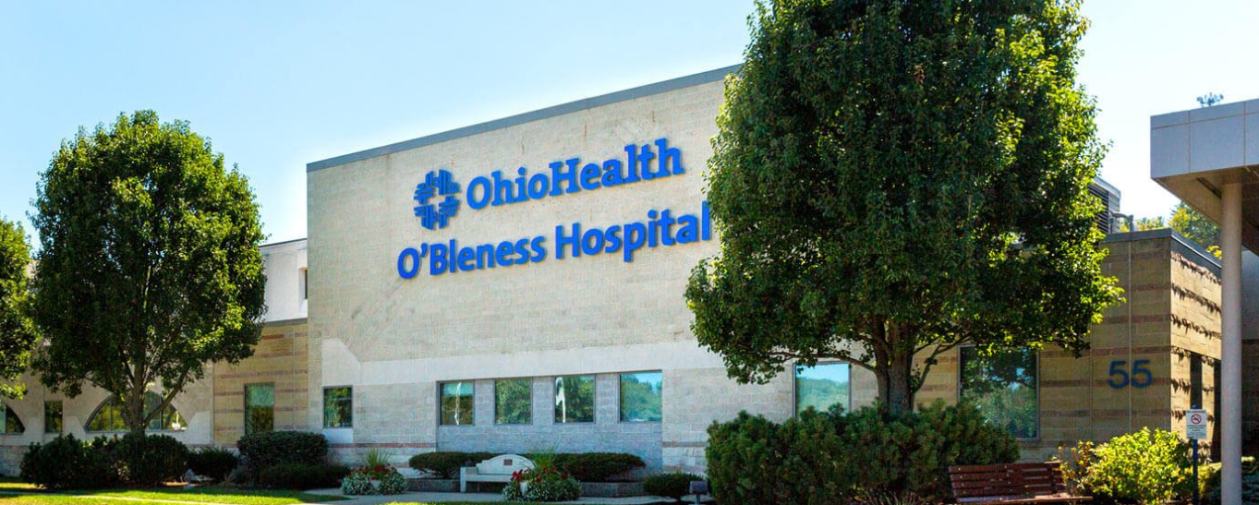
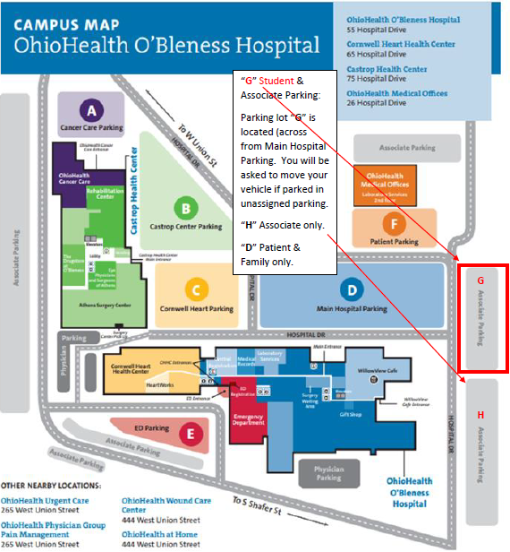

- All students are to park in the G lot

BADGES
- Protective services needs to be call ahead of time at 740-274-4343 to set up a time to get your badge; we ask that your instructor bring your entire group at the same time
- Items needed for badge pick-up
-OPID
-Driver’s license
-Credit card -- $10.00 badge fee
-Hospital placement information
Please keep your badge for your entire nursing school program. There is a $10 fee for badge replacement.

