Berger Hospital
600 North Pickaway Street
Circleville, OH 43113
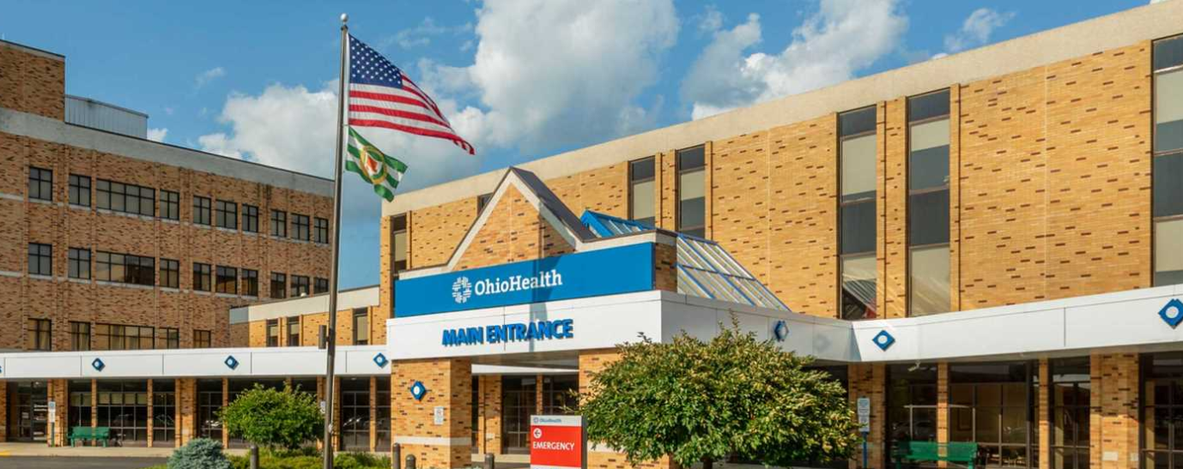
PARKING
- Students are to park in blue spots for regular, evening and weekend clinical shifts

BADGES
- Students need to contact liaisons to set up a time to get a badge made, they don’t have set hours
- Items needed for badge pick-up
-OPID
-Driver’s license
-Credit card -- $10.00 badge fee
-Hospital placement information
Please keep your badge for your entire nursing school program. There is a $10 fee for badge replacement.

- You can also pick your badge up at:
Blom Administrative Campus (Tues-Fri ONLY) 7a-3:30p (closed 12-1p for lunch)
3430 OhioHealth Pkwy
Columbus, OH 43202

