Grady Memorial Hospital
561 West Central Avenue
Delaware, OH 43015
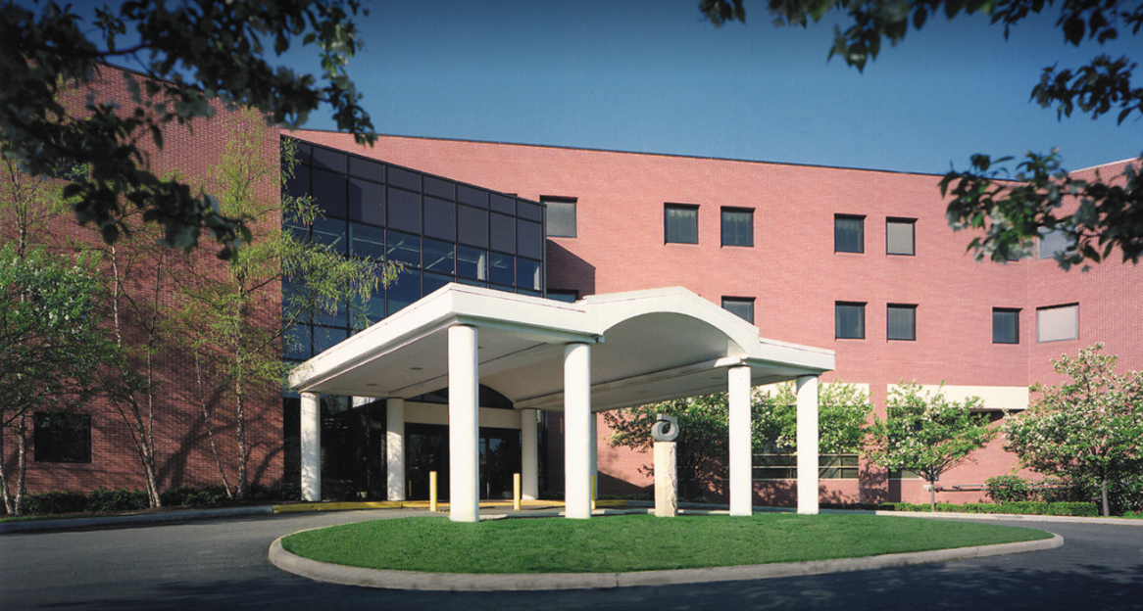

BADGES
ID center open Monday, Wednesday & Friday. If necessary, reach out to protective services at 740-615-2153.
- Items needed for badge pick-up
-OPID
-Driver’s license
-Credit card -- $10.00 badge fee
-Hospital placement information
Please keep your badge for your entire nursing school program, then turn it back in to protective services at the end of your last clinical. There is a $10 fee for badge replacement.

Badges can also be picked up at:
Blom Administrative Campus (Tues-Fri ONLY) 7:30a-4:30p (Closed 12-1p for lunch)
3430 OhioHealth Pkwy
Columbus, OH 43202

