Nursing Practice Manual

CP-016 - UNDERGRADUATE NURSING STUDENTS

PURPOSE: Southwest General (SWG) Clinical Affiliation Agreement is established with the school of nursing prior to nursing students attending any clinical experience. Coordination of undergraduate nursing student placement is approved through the Alliance for Clinical Experience Matching and Placement Program (ACEMAPP).

Attachment A: Nursing Assignment Sheet
Attachment B: SWG RN Preceptor Guide for Student Nurse

Expectations of undergraduate nursing students and clinical faculty are as follows:

      - Maintain requirements of the Clinical Affiliation Agreement as validated by the school through ACEMAPP data submission or attestation.
- Complete electronic medical record (EMR) training.
- Become familiar with SWG safety information and service behaviors.
- Adhere to all SWG policies, procedures, guidelines and nursing practice standards.
- Obtain a SWG ID badge from Human Resource department (HR) and always display the badge, above the waist.
  - Faculty will retain SWG badge for future use during approved clinical time.
  - Undergraduate nursing students will return ID badge to faculty at completion of clinical rotation.
  - Faculty will return student badges to HR. If return is to occur outside of HR business hours, faculty may place badges in interoffice SWG mail to be returned to HR.

Clinical Faculty:
- Complete instructor onboarding with the NEPD at least 2 weeks prior to clinical start date if new to or returning to SWG after a period of 12 months.
  - Pass a medication test with a score of 80% or higher.
    - Failure to score 80% on the medication test after two attempts will result in a request to assign an alternate clinical instructor.
  - Contact clinical manager (information provided by NEPD) and arrange the orientation to the unit, patient population(s) and equipment.
- Unit orientation should occur after NEPD onboarding is completed and the clinical faculty obtains an ID badge.
- Verify access and workflow for medication dispensation system on unit.
- Verify log in credentials for EMR during orientation to unit.
- Contact IT 440-816-8643 with concerns
- Notify NEPD of unresolved concerns prior to start of clinical rotation.
- Complete and provide to unit leadership/charge nurse a “Nursing Student Assignment Sheet” (Attachment A) detailing student responsibility each clinical day
- Review student documentation and adjust as necessary
- Communicate with nursing staff regarding deviations in stated assignment, assessment findings or results outside of normal limits
- Communicate with unit leadership to reserve space for pre and/or post conference.
- Coordinate observational experiences for students, as appropriate under the guidelines established in SWG Policy 306.
- Medication administration
  - Facilitate access to medications and use of the medication dispensation system.
  - Directly supervise student medication administration.
  - Co-sign/authenticate all medications administered by students in the EMR.
  - Remain accessible to nursing staff in the event that verification of student medication administration was not recorded in the EMR. The expectation is for the instructor to return to the unit as soon as possible and co-sign the medication. A second occurrence of this scenario will result in request for appointment of alternate clinical faculty.
  - Communicate with nursing staff to avoid error, omission or duplication.
- Do not:
  - Perform point of care testing (POCT) that requires additional competency verification.
  - Administer or witness blood products or chemotherapy.
  - Act as witness to high alert medication administration or disposal/waste.
  - Accept, acknowledge, modify or discontinue provider’s orders.

Undergraduate Nursing Student:
- Orient to unit with clinical faculty or preceptor at start of rotation.
- Greet nursing staff at start of each clinical shift and obtain patient report.
- Communicate with nursing staff regarding deviations in stated assignment, assessment findings or results outside of normal limits.
- Hand off outstanding tasks or care to nursing staff prior to leaving the clinical area for breaks, meals and at the conclusion of clinical shift.
- Limit skills performed and care provided to those tasks successfully achieved in the didactic and laboratory setting as determined by clinical faculty.
- Ensure direct supervision of clinical faculty or preceptor for administration of all medications.
- If participating in an observational experience to another unit / department, refrain from providing patient care. As a student, these are observation opportunities only.
- Do not:
  - Perform point of care testing (POCT) that requires additional competency verification.
  - Administer or witness blood products or chemotherapy.
  - Access medication dispensing system independently.
  - Act as witness to high alert medication administration or disposal/waste.
  - Accept, acknowledge, modify or discontinue provider’s orders.

SWG Nursing Staff
- Retain responsibility for patient assessment, care, and documentation (including IPOC).
- Communicate appropriate learning opportunities and level of clinical involvement in patient care with the clinical faculty.
- Contact unit leadership with concerns regarding clinical faculty or students.
- Contact clinical faculty for resolution of unverified medication tasks.
References:

Ohio Laws and Rules. (2022).4723-5-01 Definitions. Legislative Service Commission http://codes.ohio.gov/oac/4723-5-01

Ohio Laws and Rules. (2022). 4723-5-12 program Policies. Legislative Service Commission http://codes.ohio.gov/oac/4723-5-12.

Ohio Laws and Rules. (2024). 4723-5-20 Responsibilities of faculty, teaching assistants, and preceptors in the clinical setting. Legislative Service Commission http://codes.ohio.gov/oac/4723-5-20.

Ohio Laws and Rules. (2022). 4723-5-13 Nursing Education Program. Legislative Service Commission http://codes.ohio.gov/oac/4723-5-13.

Policy 741-Medication Safety. (2020). Southwest General Hospital Policies. Intranet.

APPROVED:
Nursing Practice/Standards Committee: 10/20/2016, 06/28/17, 10/21/19, 04/2022, 7/2024

VICE PRESIDENT / CHIEF NURSING OFFICER
Martha Bauschka:_ Vice President / Chief Nursing Office

Attachment A
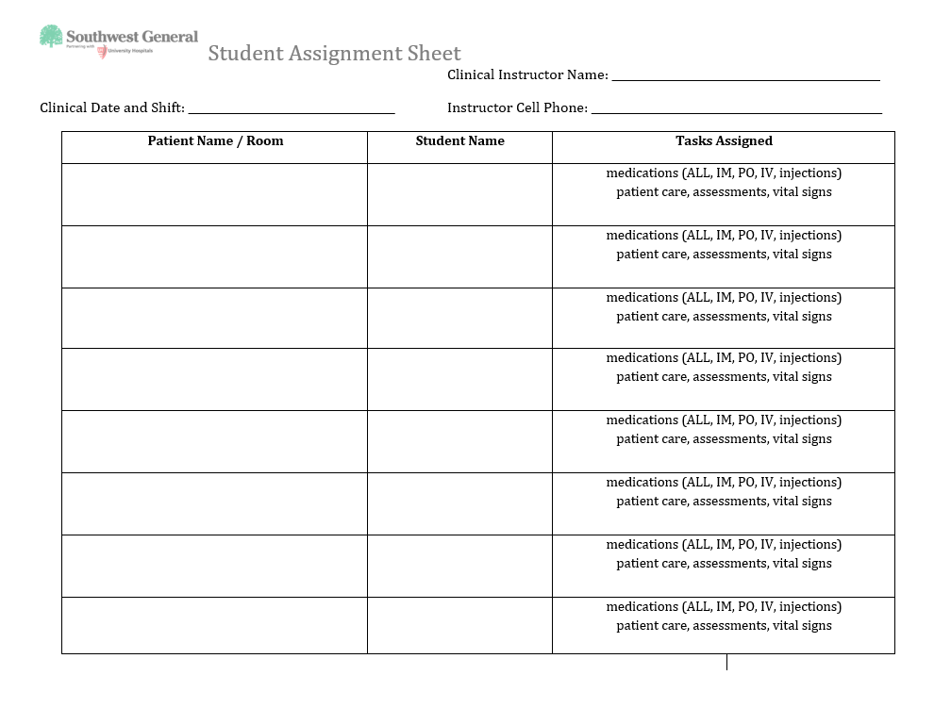

Attachment B
SWGHC RN Preceptor Guide for Student Nurse Practicum

 | Responsible Party | Information | Notes
EMR Access | NEPD | Student information sent to IT | •Student/SWGHC RN Preceptor retrieves access information from NEPD  •SWGHC RN Preceptor must assist student with single sign-on on clinical  unit.
EMR Orientation | Preceptor
Medication Administration | Student/Preceptor |  | Student:  Administers medications according to SWGHC Policy always in the presence of the Preceptor  Preceptor:  Validates the student’s medication administration in one of two ways  •Via the MAR (Preceptor signed in)  OR  •Via the MAW by witnessing each  Medication as the student Administers it (student is signed in)
School Expectations | Student/School | Information provide to SWGHC RN  Preceptor
SWG Preceptor Contact  Information | NEPD | Provided to school
Contact SWG Preceptor | Student | Set up practicum  days/times

