Dublin Methodist Hospital
7500 Hospital Drive
Dublin, OH 43016


Parking Information
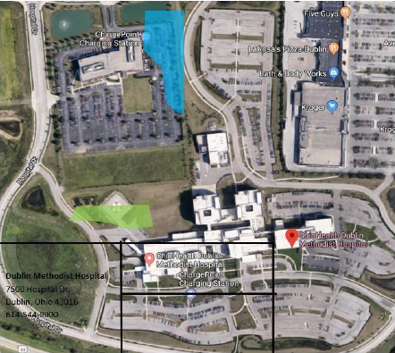

- Associate parking lot is located behind the hospital and requires badge access.
- Park in the front of the hospital your first day. Your instructor or preceptor can assist in getting you access to the gated associate lot.

BADGES:
- ID Center (In front of hospital down towards the ED) is open Mondays, Wednesdays & Fridays, need to make an appointment with protective services
-Items needed for badge pick-up
-OPID
-Driver’s license
-Credit card -- $10.00 badge fee
-Hospital placement information
- You can also get you badge at:

Blom Administrative Campus (Tues-Fri ONLY) 7:30a-4:30p (closed 12-1p for lunch)
3430 OhioHealth Pkwy
Columbus, OH 43202

Please keep your badge for your entire nursing school program, then turn it back in to protective services at the end of your last clinical. There is a $10 fee for badge replacement.

