Grant Medical Center
111 S. Grant Avenue
Columbus, OH 43215

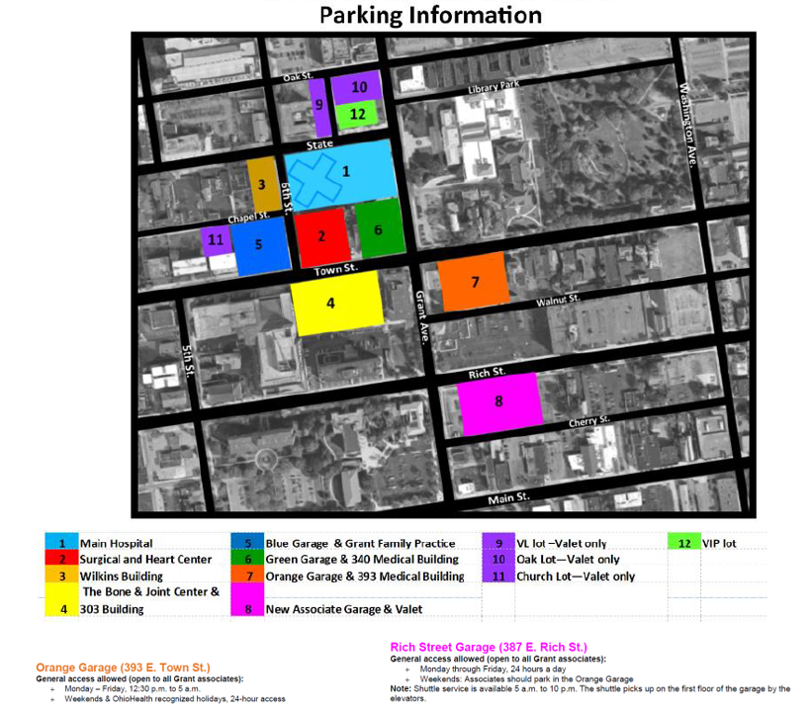
ALL STUDENTS PARK IN THE PINK GARAGE UNLESS THEY HAVE A WEEKEND/SHIFT THAT STARTS LATER THAN 3PM THEN THEY PARK IN ORANGE-PARKING NOTIFIES IF YOU DON’T FOLLOW THE RULES AND COULD RESULT IN A FINE-THIS IS NOT ALLOWED UNLESS YOU ARE A PATIENT

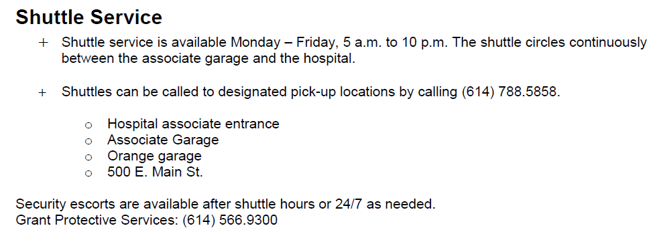

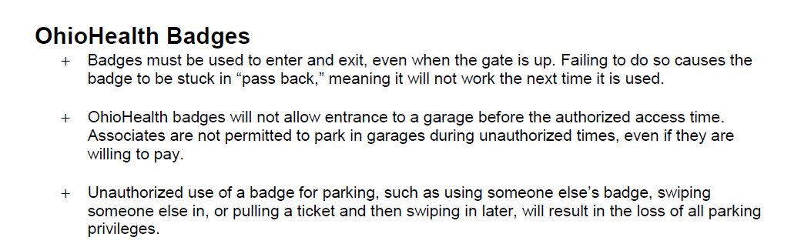
BADGE PICK UP LOCATION:
Blom Administrative Campus (Tues-Fri ONLY) 7:30a-4:30p (Closed 12-1p for lunch)
3430 OhioHealth Pkwy
Columbus, OH 43202
- Items needed for badge pick-up
-OPID
-Driver’s license
-Credit card -- $10.00 badge fee
-Hospital placement information

Please keep your badge for your entire nursing school program, then turn it back in to protective services at the end of your last clinical. There is a $10 fee for badge replacement.

