Doctors Hospital
5100 West Broad Street
Columbus, OH 43228
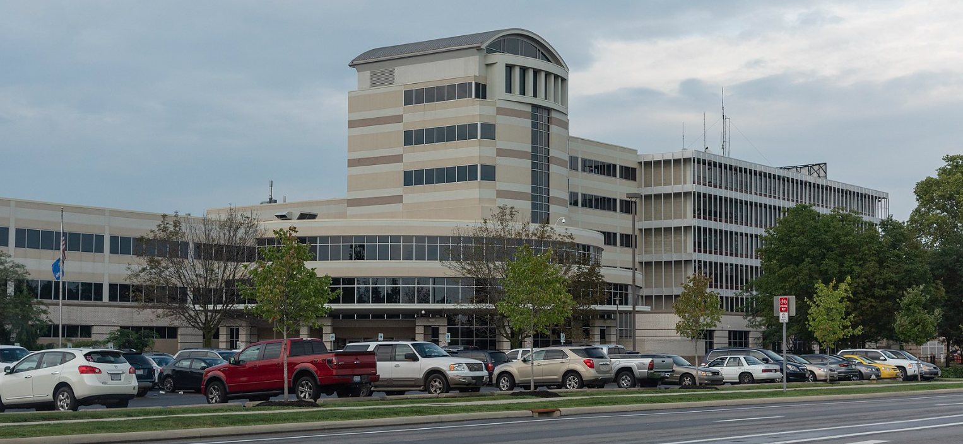
PARKING

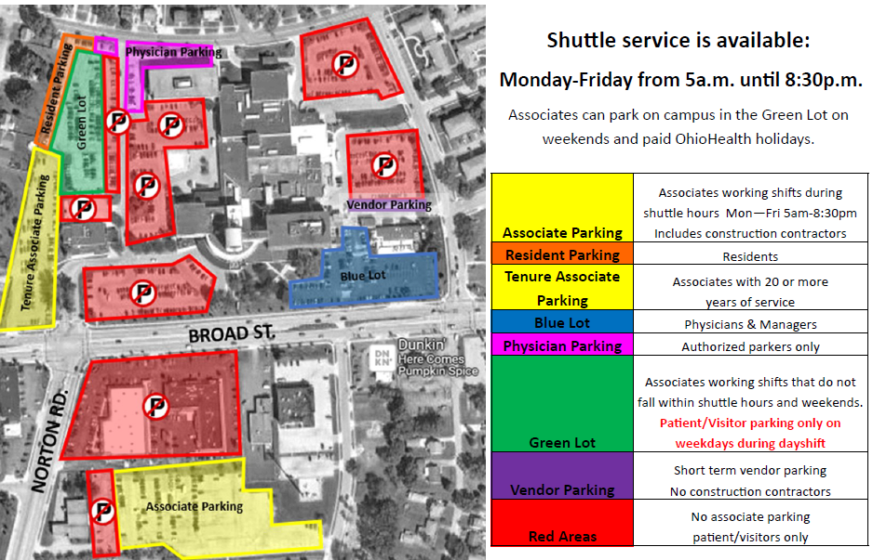
- If you are working M-F starting before 3pm, you need to park in the yellow associate parking lot
- If you are working on the weekend or after 3pm (M-F), you can park in the green lot

BADGES:

Blom Administrative Campus (Tues-Fri ONLY) 7:30a-4:30p (Closed 12-1p for lunch)
3430 OhioHealth Pkwy
Columbus, OH 43202
- Items needed for badge pick-up
-OPID
-Driver’s license
-Credit card -- $10.00 badge fee
-Hospital placement information
Please keep your badge for your entire nursing school program, then turn it back in to protective services at the end of your last clinical. There is a $10 fee for badge replacement.

