OhioHealth Registration Report Details
(Received Mondays, Wednesdays & Fridays around 10:30am)
- OPID - New student OPID for registered student
- Registration status - status of the registration, this provides information on whether the student completed the registration.
- REGISTRATION COMPLETED: They are good to go! New students will receive an e-mail with their OPID and how to set their password. Returning students do not receive an e-mail after that since their OhioHealth University account is already set up. They just need to re-set their password every 6 months. (Below is an example of 2 new students. E0AB111 has completed their training & logged into EPIC, E0AB222 has not completed training & has a training block listed at the end).
- REGISTRATION FAILED: For some reason, they were unsuccessful, so an automatic ticket will be created, & IT will contact them via e-mail within the next 48 hours. Once placed info is included in columns K & L
-If a student fails a registration, a ticket will be created with OhioHealth service desk. The ticket number is provided for a reference (SCTASK0858610)
-Failed registration ticket date - date when a failed registration ticket was created
- ID VERIFICATION FAILED: When they entered in their social and DOB, an error occurred, so an automatic ticket will be created, and IT will contact them via e-mail within the next 48 hours. Once placed info is included in columns K & L
- INVITE SENT: I have received their info from ACEMAPP and have sent the registration invite but not responded yet.
- INVITE CANCELLED: They tried to complete registration but there was an error and cancelled the link, or they tried too many times and were unable to try again since 3 is the limit. This status also shows up when a manager cancels the invite.
- NDA ACCEPTED: They did sign the non-disclosure agreement and that means they haven’t fully completed registration. They need to go back to the link and start over. Check with the student if they are having issues completing the registration.
- Training assignment ticket - ticket number for student training assignment
- Training assignment ticket date - date when student training assignment ticket was created
- Curriculum Name - name of the curriculum assigned to the student in the LMS
- Curriculum Complete Date - date when the student completed assigned curriculum
- CareConnect/Epic login - student login name for CareConnect/Epic
- CareConnect/Epic block - shows if the student has a training or other blocks
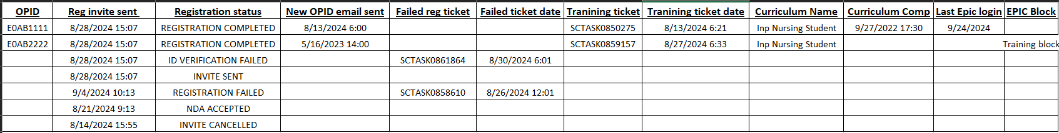

- Many students are listed twice, if you see an invite sent/registration failed/ID verification failed but also a registration completed line, that means that they did successfully finish and it’s showing both their previous and current status. Focus on finding that registration has been completed.
- If you happen to see that someone has a training block but also no Inpatient Nursing Student listed in column O, please notify me so I can check to see if there was an error with CareConnect.
- This report has now taken place of me sending lists of those who haven’t completed registration, so please utilize as it will be sent 3x a week. I’ve had many instances already when students are on the unit without access and it was due to them not having completed registration, which was clear in the report. Please keep up with this prior to during your start dates along with checking LMS modules in OhioHealth University accounts. There will be spot checks, if needed there is an instruction document on how to do so on the ACEMAPP landing page under the liaison tab.
- The report captures registrations sent in last 45 days.

October 2024

