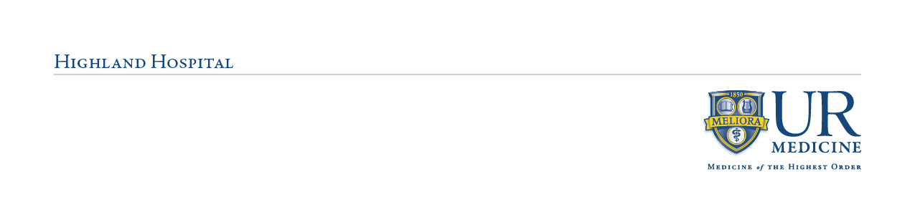
Clinical Instructor Orientation Instructions
- If new to URMC, please look for an email to complete your account initiation

- Instructors must initially complete Faculty Orientation and all assigned mandatory modules in MyPath/Achieve and then annually to be compliant. To access modules, follow the directions below:

- For new instructors, please use your school or personal email when self-registering for a guest account with this link: https://rochester.csod.com/selfreg/register.aspx?c=hh-faculty. Once your account is created, the Faculty Orientation will download within a few hours. See below on instructions for logging back in.

- For returning external faculty, use this link: https://rochester.csod.com/login/render.aspx?id=externaluserlogin. If you are unable to access your account or need to reset your password, please contact achievesupport@urmc.rochester.edu

When logging in, be sure to use the GUEST USER login on the left!
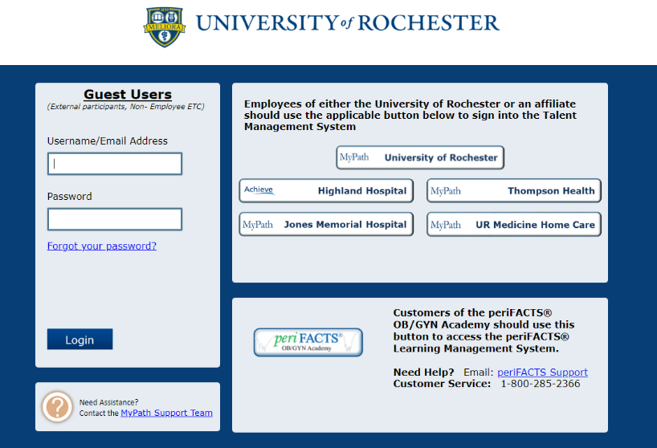

- For employees of Highland and affiliates who are also clinical faculty: you will receive annual training in your Achieve or MyPath transcript. Please email achievesupport@urmc.rochester.edu if you do not see it. If you have already completed modules through your hospital, please submit your transcript to the above email and to Roxanne_Cannarozzo@URMC.Rochester.edu

- Please notify us if you are new to URMC eRecord or have not used eRecord in the past year: We will need to assign you to an in-person class. Once assigned, you will receive an email from eRecord scheduling with class details and access to online pre-learning. Note: Pre-learning must be completed ahead of time to attend the class. Faculty and students will not be allowed to access the electronic medical record system (eRecord) until this is completed.

- Reach out to manager(s) to schedule a unit orientation and shadow (initially and annually) before your first clinical day

- At least two weeks prior to the first clinical day, all faculty instructors and students must submit the following to Support Services at hhservline@urmc.rochester.edu:
  - A professional headshot in JPEG/PNG format saved as the student or instructor’s first and last name and role (please note if the photograph submitted does not comply with Support Services identification standards, they may refuse the right to issue an ID badge until a proper photo is submitted). Please make a note of the assigned unit.
  - Parking registration form (found in ACEMAPP) completed with vehicle license plate, make, model, color, and year
  - A copy of a valid NYS or out of state ID

- Notify inform Support Services via email or (585) 341-7378 when you will be picking up ID badges. Weekend faculty instructors pick up badges from Security in ED unless alternate arrangements are made ahead of time with Support Services. When contacting Support Services, please note that the badges are for a weekend group.

- The required documents must be sent to Roxanne_Cannarozzo@URMC.Rochester.edu, dropped off in the NPD office, or faxed to 585-341-0433 before clinical:
  - Annual Achieve/MyPath transcript showing completed Annual Faculty Orientation and Mandatories
  - Stryker competency form (only first-time Highland instructors)
  - Initially, annually, and if instructing on a new unit: Annual Faculty Checklist and Clinical Instructor Orientation form (filled out with a unit leader). You will then be authorized for Pyxis use.
  - Before or on the first day of clinical: Student Orientation Attestation form

- After unit orientation, go to Support Services on the 1st floor to:
  - Obtain your Highland Hospital Clinical Instructor ID and student badges (refer to note below*). For UR affiliate employees, bring your ID badge. For all others, bring a form of ID.
  - Register for parking (if desired). If you already pay for parking at any UR affiliate, please let Support Services know. Please have available your UR ID or parking permit, license plate, make & model, color, and year of your vehicle.
*Note: It is the responsibility of you and your students to always wear Highland ID badges while on site. The replacement fee is $10. At the end of the semester, instructors must return all ID badges to Support Services. However, instructors and students expecting to return to Highland for future clinicals may keep their ID badges and contact Support Services for re-activation at the beginning of each semester.
- If desired, please arrange for booking a conference room space with the following contacts: For FMC clinicals, please contact Joyce Riola at joyce_riola@urmc.rochester.edu or (585) 341-0598 with specific dates and times. For all other clinicals, contact Desire Dodds in Support Services at desire_dodds@urmc.rochester.edu or (585) 341-7378. If Desire or Joyce are unable to make sufficient room arrangements based on your needs, please contact Nancy Kliss at Nancy_kliss@urmc.rochester.edu or (585) 341-6711 or Stephanie Schechter at stephanie_schechter@urmc.rochester.edu or (585)341-7344.

- If you are interested in having your students participate in Safe Patient Handling and Mobility equipment, reach out to Rob Masterman (robert_masterman@urmc.rochester.edu) to schedule training.

Please encourage your students to watch for emails for account creation and eRecord training. If you have any questions, please don’t hesitate to reach out. Welcome to Highland!

Sincerely,
Highland Hospital Nurse Professional Development Team
(585)341-6709

