Accessing OhioHealth University (LMS)

1. Open the OhioHealth University website.
2. Click on the Hospital Volunteer Login button.

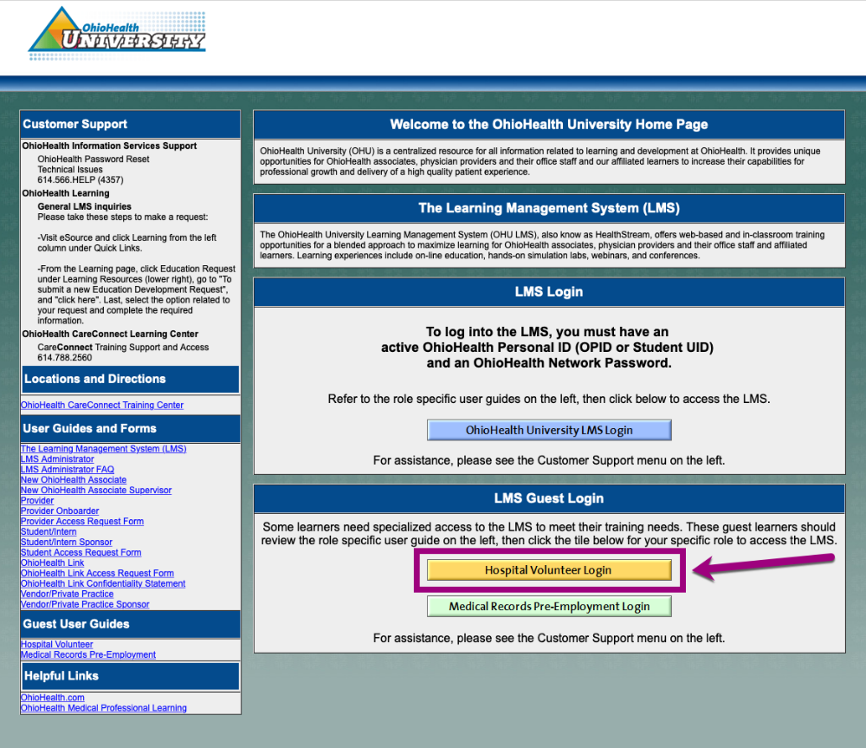

3. Login using the User ID and Password provided by OhioHealth. Contact NursingStudent@ohiohealth.com for ID and Password for first time account log-in.
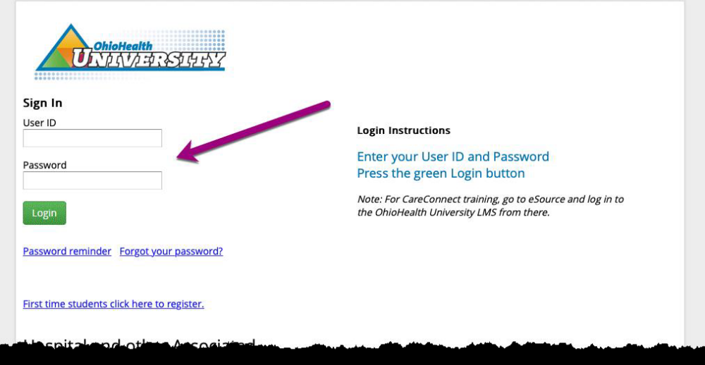

4. If this is your first time logging in, you will be prompted to reset your password.
5. For future access, use your new password to access OhioHealth University.

Student and Instructor LMS Module Completion Reporting

Single-Student Lookup

1. From the OhioHealth University home screen, click the People tab, then click the Manage Students link located under the Student Management heading.

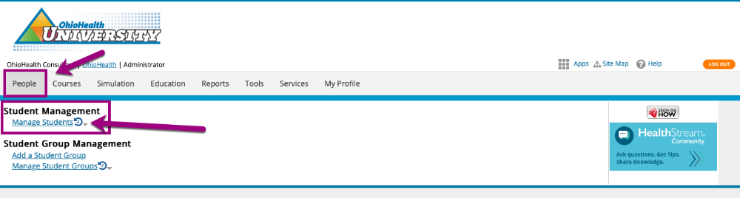

2. Enter the name or User ID of the student you’re searching for, then click the Search button.
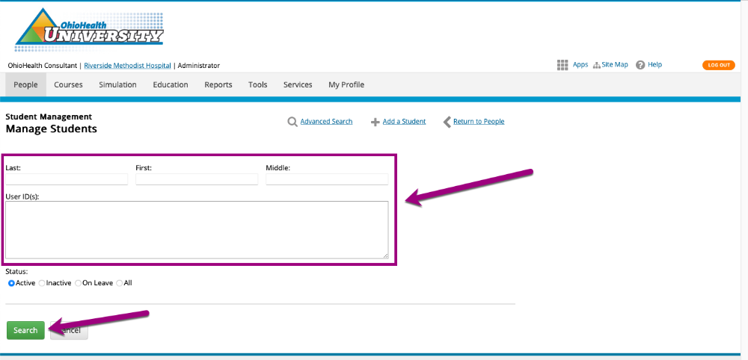

Student and Instructor LMS Module Completion Reporting

Single-Student Lookup

1. From the OhioHealth University home screen, click the People tab, then click the Manage Students link located under the Student Management heading.

2. Enter the name or User ID of the student you’re searching for, then click the Search button.

3. Click the student’s name to view their learning information.

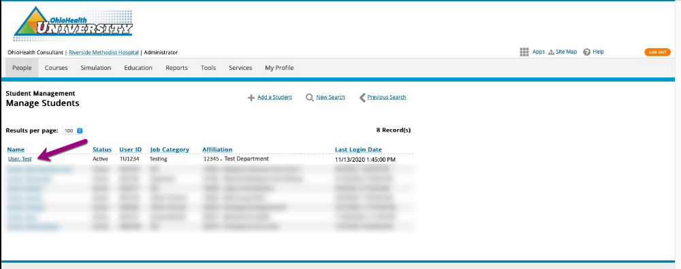

Group Reporting

1. From the OhioHealth University home screen, click the Reports tab, then click the Assignment Completion report you want to run under the Education Reports heading.

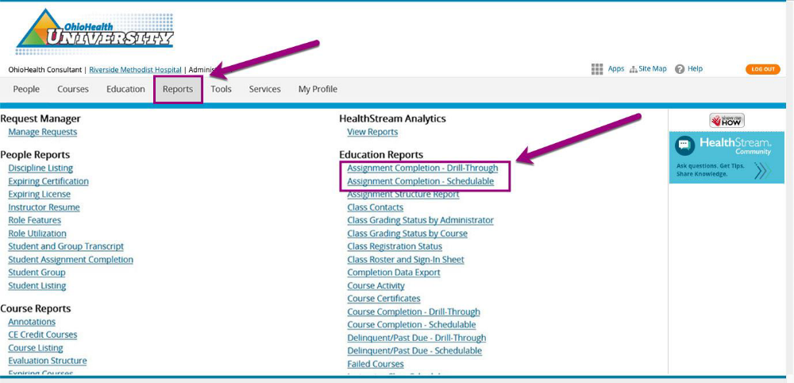

2. Select the Status Method radio button and select the date range. Any assignments that are due within this date range appear in the report.

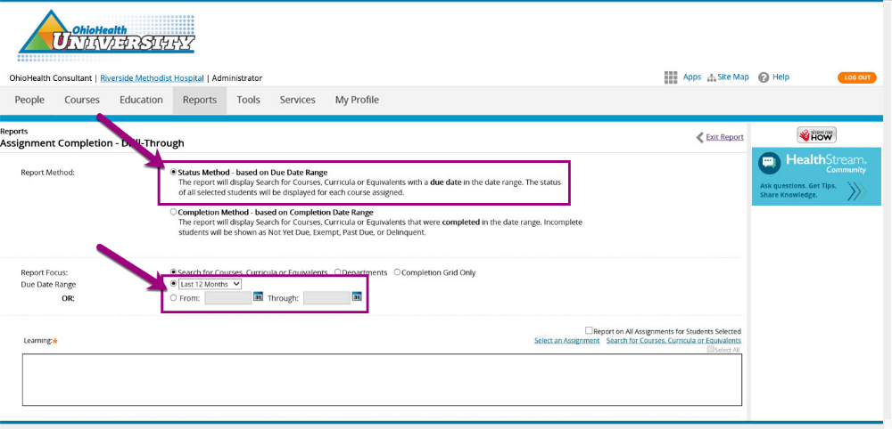

3. Ensure that the Report on All Active Students and Include Student User ID checkboxes are both selected, then click the Continue button.
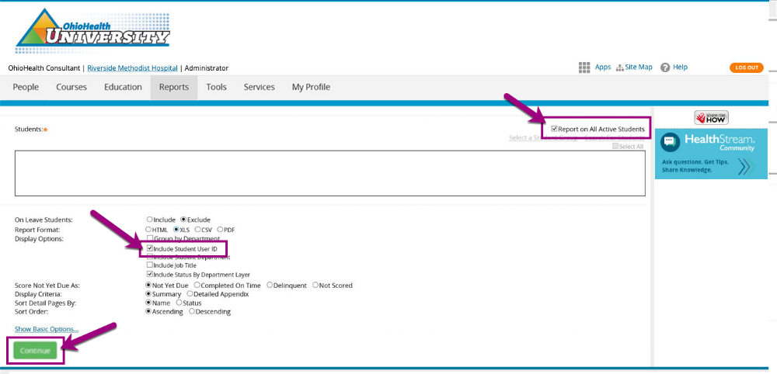

4. The report displays. Click the Export button to output the data to a Microsoft Excel spreadsheet.
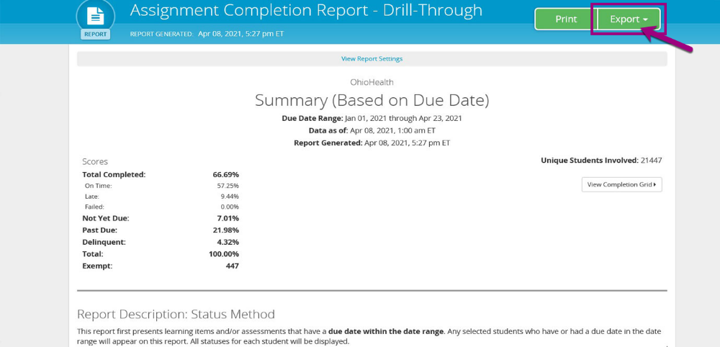

August 2021 Page 17

5. Click the second tab on the bottom of the spreadsheet to view the report data.

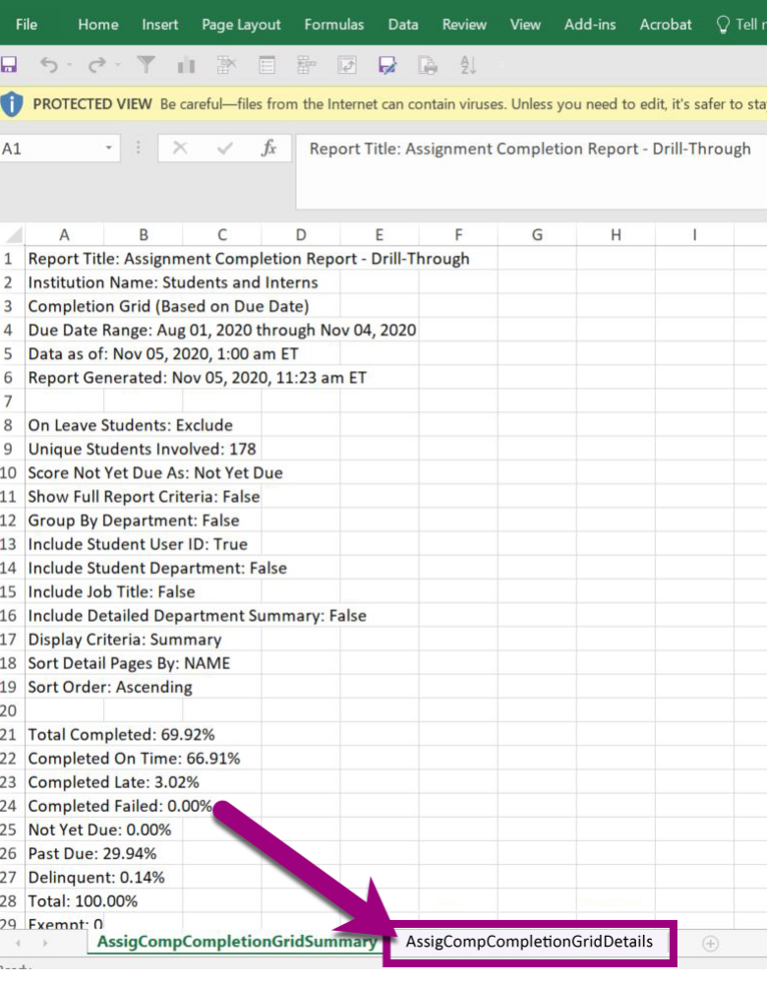

Use this data to simplify student management tasks such as:
- Copying the column of current Student OPIDs into the request sheet you send to NursingStudent@ohiohealth.com.
- Identifying student names and OPIDs who are no longer a part of your program. Send the list to Susan.Falconi@ohiohealth.com to have them removed from OhioHealth University.

LMS Reporting Webinar
Review this webinar recording for more information about running reports and managing students & instructors.

