Shelby Hospital
199 W Main St,
Shelby, OH 44875

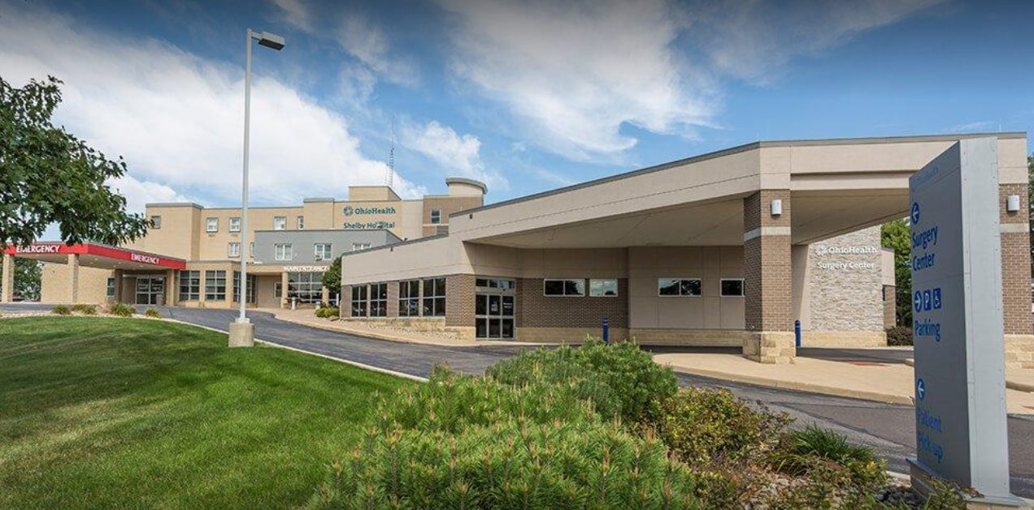

BADGES (PICK UP AT MANSFIELD)
- Protective Services Office-ID Center
-Open Monday through Friday 7:30a-2:30p
- Items needed for badge pick-up
-OPID
-Driver’s license
-Credit card -- $10.00 badge fee
-Hospital placement information
Please keep your badge for your entire nursing school program. There is a $10 fee for badge replacement.

