PICKERINGTON MEDICAL CAMPUS
1010 Refugee Road
Pickerington, OH 43147

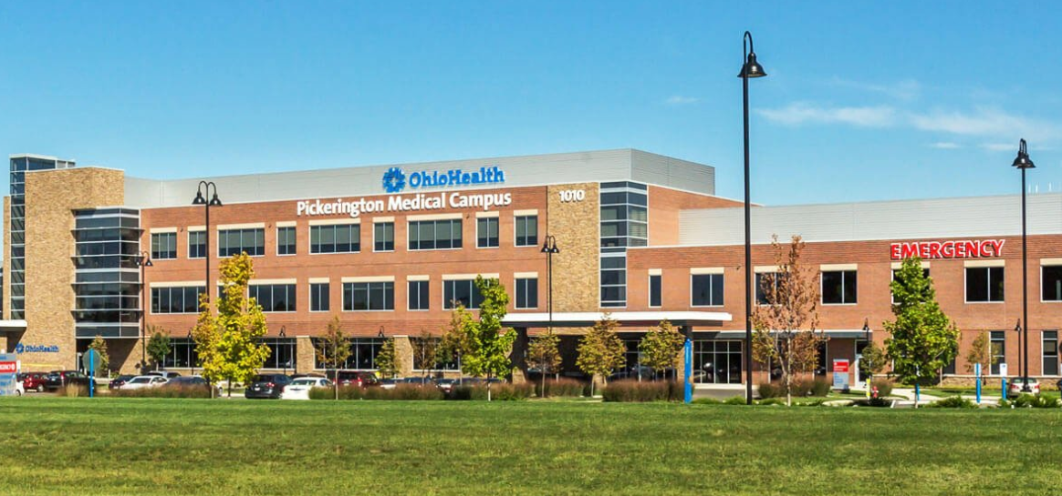

PICKERINGTON MEDICAL HOSPITAL
OPENING IN 2023
