Van Wert Hospital
1250 S Washington St
Van Wert, OH 45891
(419) 238-2390

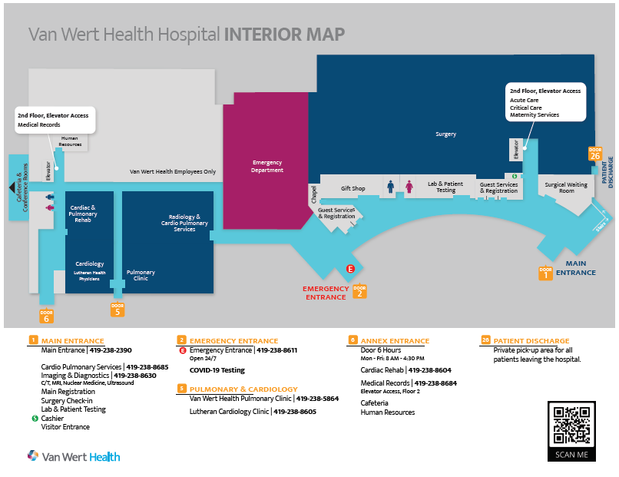
Parking: No specific spots reserved for staff/students, so any location
Badges: You will need to email a headshot, with a plain background, to Emily Lichtenberger. (emily.lichtenberger@ohiohealth.com) Badges will be able to be picked up on your first day at ED guest services. There is no charge, please make sure to turn your badge in at the end of your last clinical.

