

Parking Guidelines for Highland Hospital Clinical Nursing Experience

Due to the high census within the hospital, parking availability for patients, visitors, and staff has become extremely limited. While we highly value the contribution that students bring to the hospital, our priority must remain with making sure that our patients and visitors always have readily available parking spaces.
No student parking will be allowed at South Avenue Garage or any on-site garages at Highland Hospital on Monday-Friday, from 7am-4pm (apart from the exceptions noted below). Students or faculty who do not wish to participate in parking must find available parking on the streets surrounding the hospital or plan for alternate transportation methods to and from the hospital. Please take note of street sign rules and regulations. Security is available for escort if requested.
It is mandatory that all students and faculty instructors submit a completed parking registration form and copy of valid ID to hhservline@urmc.rochester.edu prior to their first clinical day regardless of parking status. Support Services is available for questions Monday – Friday 7:00AM to 4:00PM at (585)341-6833.

Weekday Day Shift Clinical Rotations and Day Shift Capstones

Students must park at the East End Garage (shuttle map below) from 5:45AM to 8:35PM Monday – Friday. Please utilize only levels three and above. The drop-off and pickup location will be on the ground floor by the Scio Street North Entrance. The shuttle bus service runs from the East End Garage to the Highland Hospital Main Entrance loop and back at designated times:
- 5:35AM – 9:20AM and 3:35PM-5:50PM every 15 minutes.
- At all other times, every 30 minutes.

Garage entry key cards can be purchased through the Highland Hospital Support Services office Monday – Friday 8:00AM to 4:00PM (585-341-7378). If unable to pay for and pick up key card ahead of time, please park in Main Parking Garage on your first day and obtain a validation ticket from Support Services.
- $25 per key card
- Please call Support Services at 585-341-7378 to order replacements, if necessary.
- Key card refundable if returned when finished. Note: Check will be sent to address on file unless otherwise specified.

Evening, Night, and Weekend Clinical Rotations and Capstones

Students must park in Professional Office Building (POB) lot after 2:00PM. If parking registration and badge access are not set up ahead of time, please collect ticket at gate. Once ID badge is picked up, use badge to scan in/out of garage. Security in Emergency Department can alternatively validate tickets on the first day. Note: ID badges for weekend clinical rotations can be picked up from Security in ED.

URMC affiliate students

Any student affiliated with URMC should park in South Avenue on top level during day shift clinicals at no cost. This ramp garage is located at 885 South Avenue, a short walk from the hospital. Upon entering the South Avenue Garage, please use your ID badge to pass through the gate. For your first clinical day only, press the button to enter and exit the garage or notify security at (585)341-6899. Students who are Highland employees should park in South Avenue garage when acting in the student role. When working as an employee, they should use their assigned employee parking site. For evening, weekend, or nighttime clinicals, please park in Professional Office Building.

Faculty Instructors

Instructors that are Highland Hospital employee must park according to their assigned parking spot. Otherwise, please reach out to Support Services to enroll in our 12 free parking passes program. If you expect to be on site for more than 12 shifts per semester, please notify Support Services to extend program.

For day shift clinical rotations, please park in South Avenue Garage. For evening, night, and weekend clinical rotations, please park in Professional Office Building lot. Exception: Instructors who pay for parking at URMC affiliate can always park in Professional Office Building lot.

Contact Information:

Highland Hospital Parking Office: (585)341-6833 or hhservline@urmc.rochester.edu
7:00AM – 4:00PM

East End Garage Parking Office (located inside Scio North entrance): (585)602-0964
Monday through Friday 8:00AM – 4:30PM, closed for lunch from 2:00PM – 2:45PM

East End Garage Security: Contact Public Security at (585)275-3333
On-site Monday through Friday 7:00AM – 11:00PM

For shuttle service questions, email transportation@rochester.edu
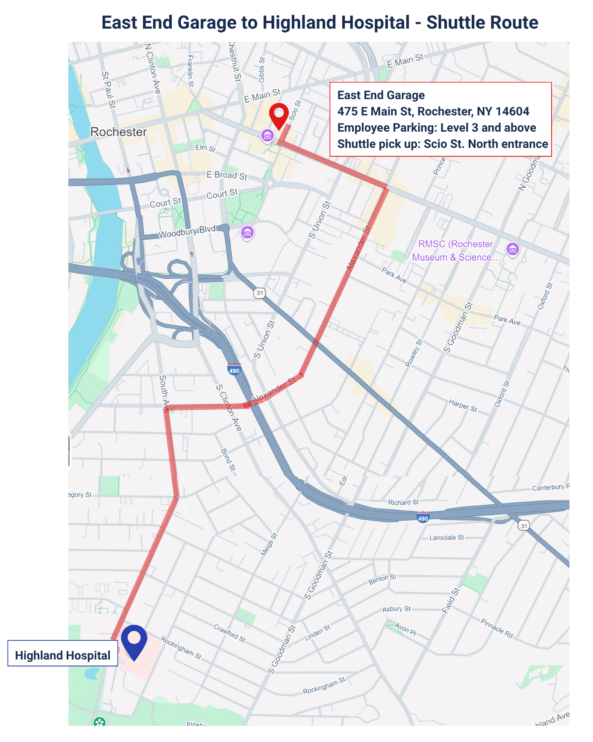


Highland Hospital South Ave Shuttle Schedule

