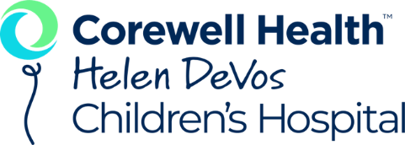
Neonatal Tour Request Form
The Neonatal Intensive Care Unit stakeholders and management has recommended that tours of the NICU be restricted to students who are in their Pediatric rotation and have potential to be placed in the NICU for an observation day. Tours must be pre-approved by Lindsey Chandler or Elle Seagrave, Educators for Neonatal Services. Tours will be of the common areas in the NICU including the greeter’s desk, family waiting areas, and around the halls of the unit. During the tour, students will not be allowed to enter the nurseries.
Students must follow the NICU visitation guidelines of:
- Coats, bags, and other belongings should not be brought to the unit or should be stored in a locker.
- Please do not come to the NICU if you do not feel well or you have been sick in the last week.
- Student should wear appointed uniforms, short sleeves, no watches, rings or jewelry from the elbow down and must wash their hands in the scrub room prior to the tour
- Student tours are only allowed if accompanied by a NICU educator.

Please fill out the information below and submit via e-mail to Lindsey Chandler and Elle Seagrave (lindesy.chandler@helendevoschildrens.org and elle.seagrave@spectrumhealth.org ) for approval. This form must be received 2 weeks prior to the planned tour date. Expect follow up to your submission within 1 week.
School Name:
Clinical Instructor’s Name:
Type of clinical rotation:
Tour Request:
Approximate date for tour:
Number of students expected for tour:
Other information or Comments:

